Nanomaterial Procedure Checklist
PI, Spokesperson, or Research Lead |  | [PI or Spokesperson] |  |  | SOP or Proposal # |  | [SOP or Proposal #]
Author |  | [Author] |  |  | Date |  | [Date]
Author’s Job Title |  | [Author's Job Title] |  |  | Directorate |  | [Directorate]
Other Workers |  | [Workers]
Location |  | [Location]
Experiment Duration |  | [Experiment Duration]
Nanomaterial Form |  | [Nanomaterial Form] |  | Nanomaterial Composition |  | [Nanomaterial Composition]
Size | [Size] |  | Shape | [Shape] | Quantity |  | [Quantity]
Description of Work
[Description of Work]

Risk Assessment
[Risk Assessment]

Additional Information (e.g., Sample Holder Description)
[Additional Information]

SLAC Approvals


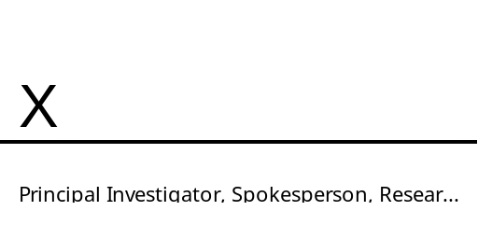
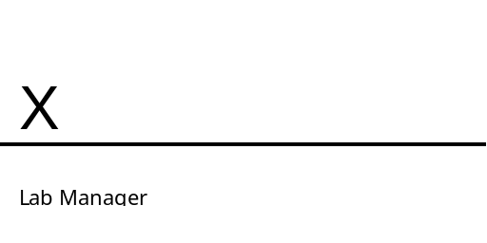
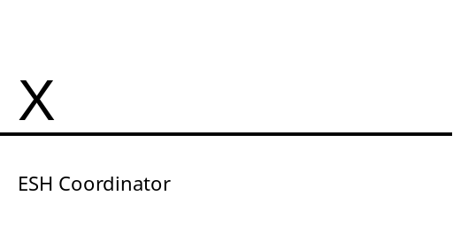

Procedural Quick Reference
Any work done with nanomaterials must have a fully approved procedure. This serves as a quick guide that highlights important reminders of the process.

Preparation
- Complete ES&H Course 161: Nanomaterial Laboratory Safety
- Post Nanomaterial signage, provided by laboratory manager, at workstation.

Perform Work
- Wear proper PPE - gloves and safety goggles (glasses, if appropriate).
- Dry Powders: Work within HEPA filtered fume hood or chamber over absorbent bench paper or alternative liner (requires prior approval).
- Liquid Suspensions: Work over absorbent bench paper or alternative liner (requires prior approval).

Transport of Nanomaterials
- Transport samples in a sealed secondary container – bottle, jar, or plastic bag.
  - Samples should be sealed at the beamline.
- Label outside of secondary container with nanomaterial composition and hazards.

Clean Up
- Wipe down work surface with paper towels and aqueous soap solution.

Waste Disposal
- Collect all nanomaterial contaminated waste (bench paper, kimwipes, tapes, etc.) in appropriately sized container – bottle, jar, or plastic bag.
- Fill out hazardous waste label and affix to container. Write “Nanomaterial” and any other relevant hazards on the hazard line.
- Deposit waste in Nanomaterial bin of laboratory’s hazardous waste cabinet.

Emergency and Spill Procedures
Powder spills within an exhaust hood can be cleaned by using paper towels and an aqueous soap solution. Liquid spills within a hood can be cleaned with paper towels and then wiped with an aqueous soap solution. For spills outside of an exhaust hood, control access to the area and immediately notify the laboratory manager.

