
DOE/SSO- LCLS Construction Safety Inspection Log

Date: 05/31/07 Thursday Time: 1:00 PM

Present:
Tom Rizzi (SSO), Jeff Logan (SSO), Michael Scharfenstein (SLAC), Andrew Leone (Turner), Morgan Spaman (Turner)

Description of Activity: DOE/SSO LCLS Construction Walkthrough

Upper Site (NEH):

Beam Dump:
A 60 ft, 9,000 lb I-beam was being rigged into position which will be used to support/suspend utilities (A&B Construction) (see picture #1). Tag lines were being used to guide the beam, and the operator was in contact with spotter. Turner indicated that they had reviewed the machine capacity (Excavator arm being used, with eye attachment) prior to the pick. Condon-Johnson work is in-progress on the soil nail wall adjacent to the suspended utilities – grouting for soil nails. A CAT excavator was working in the open cut.

NEH:
Rod busters were building rebar cages, and hanging forms prior to the next wall pour.

Building 3.1 (Equipment bldg):
Shafts have been cut and capped (tack-welded).

Research Yard (RSY):

BTH:
300 cubic yards of concrete were poured today. Form stripping is in-progress (Conco).

UH tunnel:
Spoil mucking in-progress. Tunnel heading is currently at approximately 300 feet. Noted were good safety work controls at the portal (shifter), and the PHA was signed (Affholder)

Safety Process Observations:

- Noted that a Conco employee had SRL fall protection anchored near his feet while on the top of the BTH rebar grid (see picture #2). While anchored in this manner the employee is at risk of a fall of approximately 5 feet before the SRL begins to elongate. The SRL will elongate 18 inches before it fully engages (give or take depending on the make and model, position of worker before the fall, etc.). The harness stretch factor is approximately 1 foot. Based on all of these factors and an approximate working height of 12 feet - this fall protection set-up warrants a second look.

- Suggest Conco have their Fall Protection Competent Person evaluate worker safety for those who have SRL fall protection anchored near their feet.

Safety Process Observations Follow-up (Previous Inspection) –
N\A

Proficiencies\Noteworthy Practices: (for tracking only):

- Noted fall protection measures being utilized by Conco. Conco rod busters are utilizing 100% tie-off and are employing a double SRL system to allow continuous protection while moving to new work locations on the rebar grid. (see picture #3)
- Shafts have been cut and capped (tack-welded). The covers had the corners rounded to prevent potential for cuts/abrasions. (see picture #4)
- Turner has implemented a new monthly inspection process for extension cords, spider boxes, GFCIs, and cords on power tools. Each month these items are inspected and marked with colored tape if they are in good working order. For subsequent inspections the color of the tape is changed to allow easy identification of recently inspected items.
Findings:
- Priority 1 = Finding of major significance (imminent threats to safety)
- Priority 2 = Nonconformance, deviations, deficiency of standards or procedures
- Priority 3 = Trending only, no action required unless voluntary
Priority 1 Findings
None noted

Priority 2 Findings:
- None

Priority 3 Findings: (for tracking only)
None noted.

Corrective Actions:

ONLY “priority findings 1 and 2” need to be corrected. Proficiencies and priority finding 3 items are for tracking only and do not require correction.

DOE/SSO will verify, at its discretion, that items are actually closed prior to closing the assessment in the DOE/SSO corrective action database.

Side Notes and Photographs:

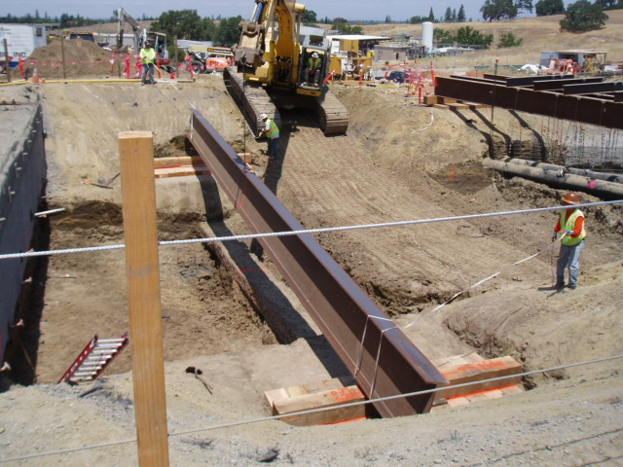
Picture #1 – A 60 ft, 9,000 lb I-beam being rigged into position

Picture #2 – Fall protection question regarding tie off points near workers feet. Worker using 2 SRLs
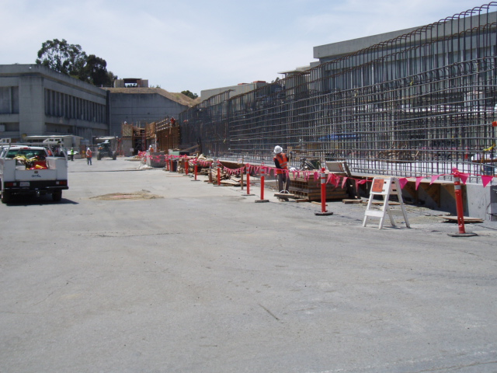
Worker using SRLs tied-off at his feet.

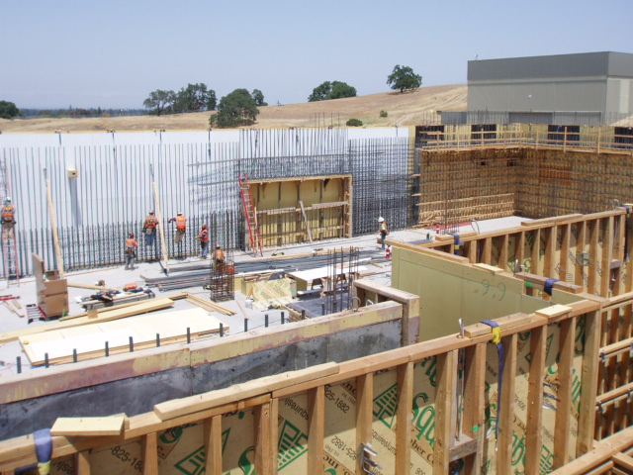
Picture #3 – Rod busters were building rebar cages, and hanging forms prior to the next wall pour.

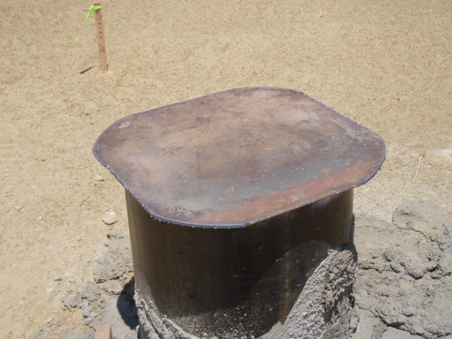
Picture #4 – The Equipment Building’s shafts have been capped and tack welded. Note the rounded corners to prevent injury.

