Preliminary Design Report (PDR) | Doc. No.  SP-391-003-31 R0 | XCS  Vacuum
LUSI XCS XRT and Hutch Vacuum Preliminary Design Report

Prepared by:
Eric Bong | Signature | Date
XCS Lead Engineer
Approved:
Aymeric Robert | Signature | Date
XCS Instrument Scientist
Approved:
Darren Marsh | Signature | Date
Quality Assurance Manager
Approved:
Tom Fornek | Signature | Date
LUSI Project Manager

Revision | Date | Description of Changes | Approved
R0 |  | Initial release

Table of Contents
1. Scope 3
2. Applicable Documents, Specifications and Codes 3
2.1. SLAC Documents and Specifications 3
2.2. Industry Specifications and Codes 3
3. XCS Vacuum System Summary 3
3.1. XRT Vacuum System 4
3.2. Hutch 4 Vacuum System 4
4. Vacuum System Design Status 5
4.1. Vacuum Profile 5
4.2. Vacuum Component Selection 5
4.3. Fabricated Parts 6
5. Controls Interface 7
6. Environmental Safety and Health Requirements 7
6.1. Electrical 7
6.2. Seismic 7
7. XCS Official Color Definition 7

Scope
This document describes the design status of the XCS vacuum system at the completion of the preliminary design phase. The status is for LUSI WBS elements 1.4.6 XCS Vacuum System, 1.4.6.1 XCS XRT Vacuum and 1.4.6.2 XCS Hutch Vacuum System. The approval and release of this document serves as a substitute to the preliminary design review for the above WBS elements.

Applicable Documents, Specifications and Codes
  - SLAC Documents and Specifications

AP-391-000-59 Engineering Review Guidelines
DS-391-000-36 Design Standards Supplement
FP-202-631-15 Fabrication of UHV Components
LCLS 1.1-302 LCLS Mechanical Vacuum Specification
SLAC-I-007-12004-001 SLAC Guidelines for Vacuum Systems
SLAC-I-720-0A24E-002 Specification for Seismic Design at SLAC
ID-391-030-16 XCS Mono Layout
ID-391-030-17 XCS Diagnostics Layout
ID-391-400-08 XCS Hutch 4 Installation

  - Industry Specifications and Codes
NEC, NFPA 70 National Electric Code
NEC, NFPA 70E Electrical safety in the Workplace
UBC 1997 Uniform Building Code, 1997

XCS Vacuum System Summary
The XCS Vacuum System (WBS 1.4.6) transports the monochromatic x-ray beam from the large offset monochromator to the diffractometer. The evacuated transport eliminates molecular-absorption and scattering of the x-ray beam and provides a clean environment for the in-vacuum x-ray optics.

The downstream interface, at the diffractometer, is a diamond window. The window is attached to the vacuum system using a Con-Flat flange. The window flange may be removed to allow the vacuum system to be directly connected to an evacuated sample environment. The upstream interface is windowless with an automatic isolation valve. Additional isolation valves are provided within the system for protection against unwanted events and to break up the system into smaller sections for ease of maintenance.

The vacuum system is pumped using ion pumps. Roughing of the system requires the use of one or more pumping carts. One pumping cart will be provided by XCS for this purpose and is included in the budget for the Hutch Vacuum WBS element 1.4.6. The vacuum system includes at least one right angle bake-able valve for roughing in each section bounded by valves. The system also includes diagnostics to monitor vacuum integrity and to aid in-situ leak detection.

XRT and in Hutch 4 will operate at better than 1x10⁻⁶ Torr.
  - XRT Vacuum System
The XRT Vacuum System (WBS 1.4.6.1) spans from the large offset monochromator to the XRT fire wall. Valves are located upstream and downstream of the large offset monochromator, downstream of the post-monochromator and downstream of the stopper at the XRT fire wall. The location of the valves allows isolation of the entire XCS vacuum system from the rest of the XRT vacuum systems, isolation of the Hutch 4 vacuum system from the XCS vacuum sustem in the XRT and isolation of each monochromator from the rest of the vacuum system to allow maintenance on nearby components without venting the monochromators or conversely, maintenance on a monochromator without venting the neighboring vacuum segments.

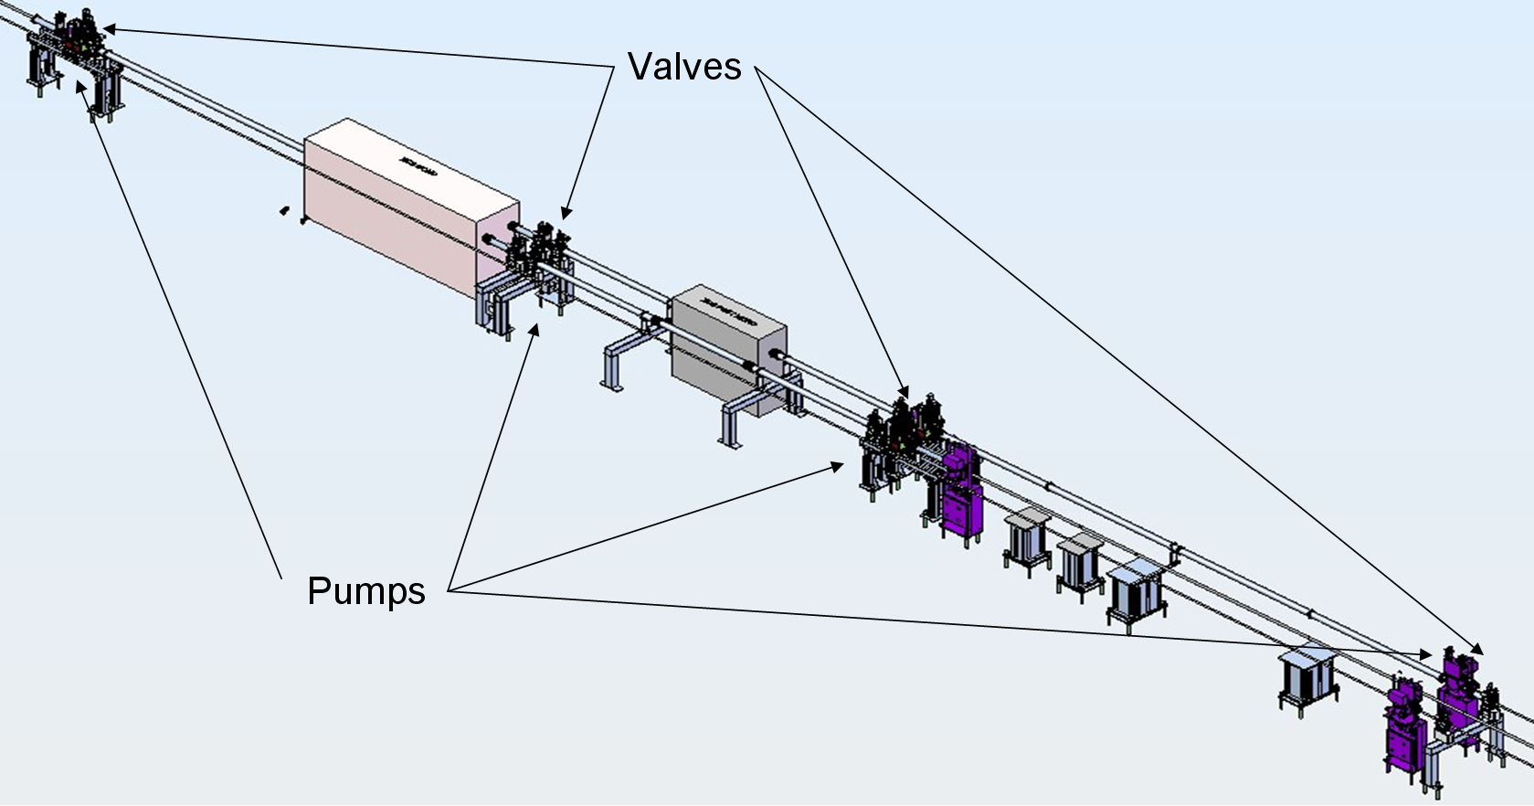
XCS XRT Vacuum System; valves bound each monochromator and separate from remaining XRT sections and H4 section.
  - Hutch 4 Vacuum System
The Hutch 4 Vacuum (WBS 1.4.6.2) spans from the XRT fire wall, through the upstream alcove and into Hutch 4, terminating at the diffractometer. Valves are located on either side of the Split & Delay unit in order to isolate it from the rest of the XCS vacuum system for maintenance. The baseline design accommodates the Split & Delay unit from DESY which is “in-air”, so two diamond windows will be provided at the air to vacuum interface. The vacuum design will accommodate a future “in-vacuum” split & delay unit.

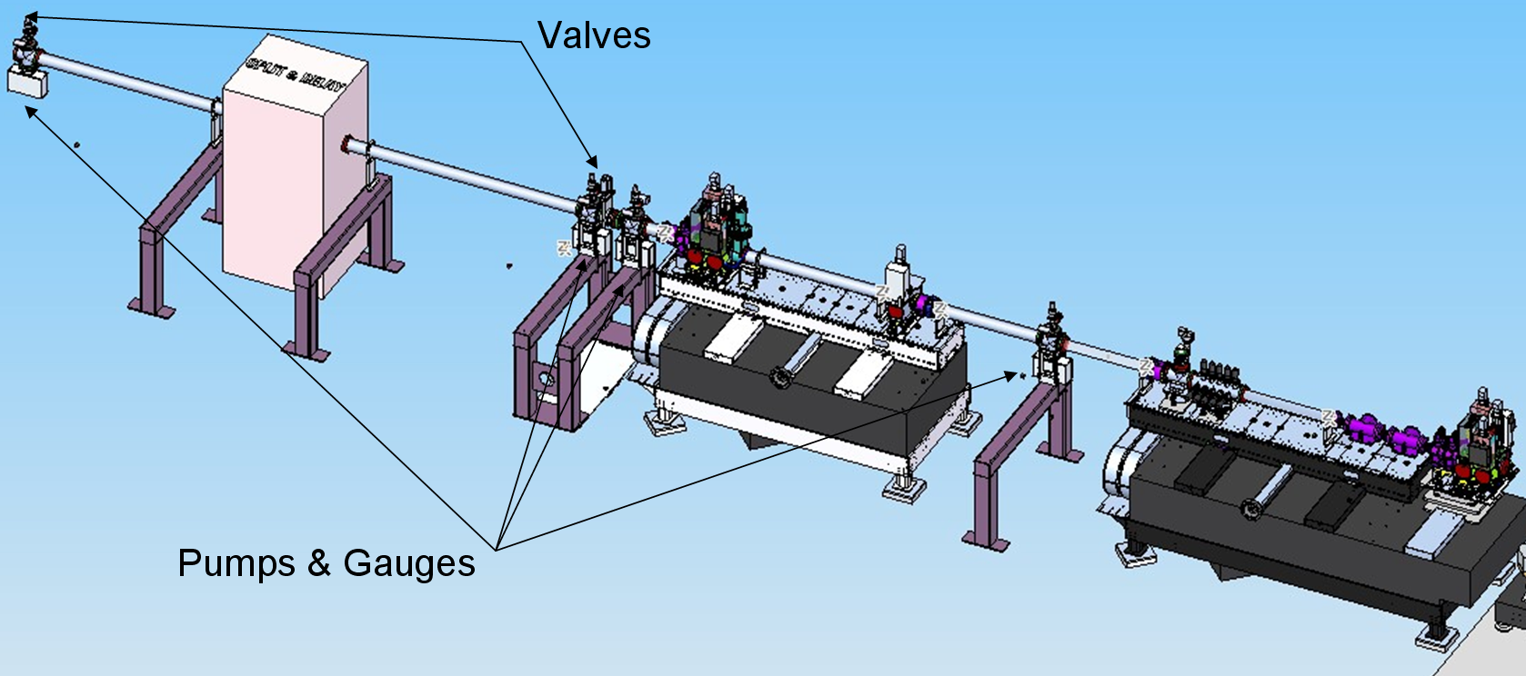
Hutch 4 Vacuum System; valves bound “Split & Delay” section.

Vacuum System Design Status
The design of the XCS vacuum system for both the XRT and Hutch 4 regions has progressed to the point where final design of the fabricated components can begin. All vendor purchased vacuum components have been identified and included in the installation and assembly design models. The floor support stands have been selected and the support methods have been identified. Initial layout of the supports has been performed and final design of the supports may commence.

  - Vacuum Profile
A vacuum profile of the adjacent CXI beam-line was calculated and far exceeded the vacuum requirements. Since the XCS beam-line contains more pumps, by comparison, it should also meet the vacuum requirements. A vacuum profile will be calculated for the XCS beam-line prior to the completion of final design. However, since the XCS contains devices for which there is no measured vacuum data, the calculation will be an estimate of the performance. If in the unlikely event that the out-gassing rates and conductance of the beam-line devices far exceeds the estimated values, additional pumping could be added to the XCS beam-line to meet the vacuum requirements.
  - Vacuum Component Selection
Industry standard vacuum components are used throughout the XCS vacuum system. Components are selected to be identical to components used in LCLS to reduce maintenance costs. All seals are metallic Con-Flat seals, welds or brazements with few exceptions. The downstream terminating window may utilize an o-ring seal; however, o-ring seals are to be kept at a minimum and only used if necessary.
All pumps will be identical 100 l/s ion pumps. At least one pair gauges will be installed in each vacuum section. At least one burst disk will be installed in each vacuum section. As is standard at SLAC, all-metal bake-able right angle valves will be included in each vacuum section for pump-out using a pumping cart. The pumping cart purchased for the XCS will be identical to the pumping carts purchased for LCLS.
  - Fabricated Parts
The XCS fabricated vacuum components are designed to SLAC vacuum standards. All chambers and bellows are of all-stainless steel. The vacuum support designs use many parts similar or identical to vacuum supports used in the LCLS Dump region. The support designs are modular so that common parts can be used in a variety of installed configurations.

The vacuum tube design is identical to the XTOD XRT designs with the exception of length. The Quick-Clamp bellows designs used in the Hutch 4 are identical to the XPP shielded bellows design. The tube supports use an adaptation of the double pivot thermal expansion compensated design used in LCLS. The pump supports support the pump cross to allow removal of the pump for service.

The diamond window will utilize the same design used at other synchrotron laboratories where the diamond is “sandwiched” between o-rings mounted between the flange and a cover-ring to minimize stresses in the diamond material.

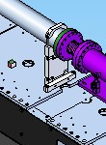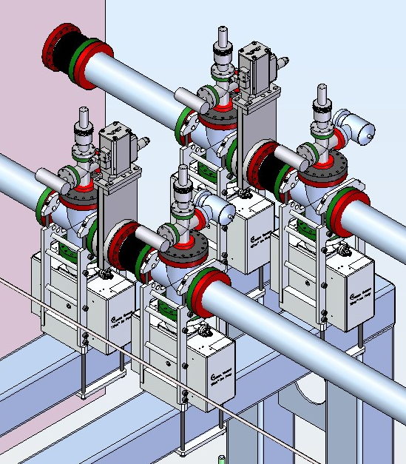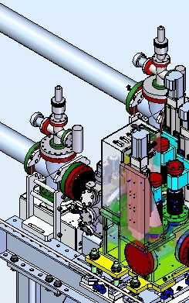
XCS Vacuum Components; drift tube support (left), gang pump supports (center) and rail-stand pump support (right) utilize modular design concept to maximize use of common parts.

Controls Interface
The controls interface is identical to previously installed LCLS vacuum systems. The quantities and locations of the vacuum components are communicated to LUSI Controls through the LCLS component database.

Environmental Safety and Health Requirements
  - Electrical
The electrical safety of vacuum system connectors was addressed during the LCLS vacuum system reviews and acceptable high voltage connectors were identified at that time. The XCS vacuum system will utilize the same connectors at high voltage vacuum components.
  - Seismic
SLAC is situated in an active seismic zone. All hardware exceeding a weight of 300 Lbs. and / or mounted greater than 4 feet above the floor will be reviewed by a SLAC “citizen safety committee” for seismic loading resistance. Applicable loads and structural behavior will be evaluated for compliance to the 1997 version of the uniform building code and SLAC publication SLAC-I-720-0A24E-002: “Specification for Seismic Design of Buildings, Structures, Equipment, and Systems at the Stanford Linear Accelerator”.

No vacuum component in XCS exceeds 300 lbs.
  - Pressure Vessel Code
Although the pressure differential between the interior of the vacuum envelope and atmosphere is less than 15psi, a burst disk is included in each vacuum section to prevent over-pressurization during a vent or purge process.

The diamond windows, since they are mounted to the vacuum system, are protected against over-pressure by the burst disks included in the vacuum system. However, the diamond window design will be submitted to Hazardous Experimental Equipment Committee for review.

XCS Official Color Definition
All painted surfaces will be painted the official XCS color (Purple), Federal Standard 17100.

